Type Your Neighborhood’s Name Here
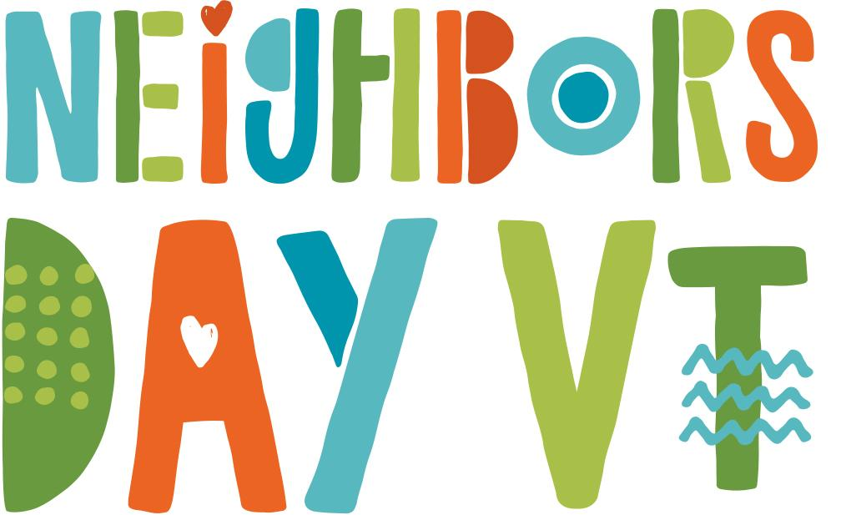
Saturday, June 1, 2019
LOCATION: Enter your location here
TIME: Enter your time here
INFO: Enter your event’s information here

